Lab 04
Made by: Abdul Wasay
class:BSE-1A
Reg. No: FA25/BSE-002

Acitivity1:

import java.util.Scanner;

public class Activity1
{
public static void main(String args[])
{
Scanner console = new Scanner(System.in);

System.out.println("Enter a year:");
int year = console.nextInt();
boolean isLeapYear = (year % 4 == 0 && year % 100 !=0) || (year % 400 == 0);
System.out.println(year+ " is a leap year? " + isLeapYear);

}//end of method main
}// end of class

Output:

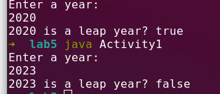

Activity 2:

import java.util.Scanner;

public class Activity2
{
public static void main(String args[])
{
Scanner console = new Scanner(System.in);

System.out.println("Enter an integer ");
int number = console.nextInt();

if( number % 5 == 0 )
System.out.println("HiFive");
if( number % 2 == 0)
System.out.println("HiEven");
}//end of method main
}//end of class

Ouptut:

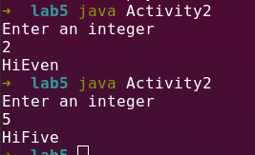

Activity 3:

import java.util.Scanner;

public class Activity3
{
static Scanner console = new Scanner(System.in);
public static void main(String args[])
{
double wages, rate, hours; // Line 1

System.out.println("Line 2: Enter the working hours: ");
hours = console.nextDouble();

System.out.println("Line 5: Enter the pay rate: ");
rate = console.nextDouble();

if ( hours > 40.0 )
wages = 40.0*rate + 1.5*rate*(hours-40.0);
else
wages = hours * rate;//Line 11
System.out.printf("\nLine 12: The wages are $%.2f %n",wages);

}//end of method main.
}//end of class

Output:

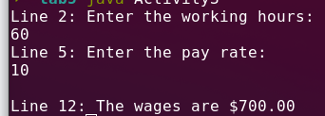

Activity 4:

import java.util.Scanner;

public class Activity4
{
public static void main(String args[])
{
Scanner console = new Scanner(System.in);

int score;
System.out.println("Enter score: ");
score = console.nextInt();

if (score >= 90)
System.out.println("The grade is A");
else if (score >= 80)
System.out.println("The grade is B");
else if (score >= 70)
System.out.println("The grade is C");
else if (score >= 60)
System.out.println("The grade is D");
else
System.out.println("The grade is F");
}//end of method main
}// end of class

output:

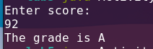
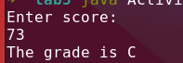
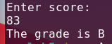

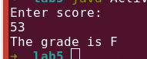
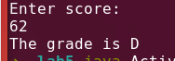

Activity 5:

import java.util.Scanner;

public class Activity5
{
public static void main(String args[])
{
Scanner console = new Scanner(System.in);

int number;
System.out.println("Enter 1, 2, or 3: ");
number = console.nextInt();

switch (number)
{
case 1:
System.out.println("You entered 1.");
break;
case 2:
System.out.println("You entered 2.");
break;
case 3:
System.out.println("You entered 3.");
break;
default:
System.out.println("That's not 1, 2, or 3!");
}//end of switch body
}//end of method main
}//end of class

Ouput:
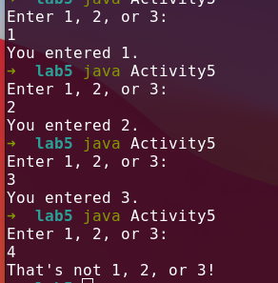

Task1:

!(x > 10) , true
x <= 5 || y < 15, true
( x != 5 ) && (y!=z), true
x >= z || (x + y >= z), true
( x <= y - 2) && (y >=z) || ( z -2 != 20), true

Task2:
Output:
x == y: false
x != z: true
y == z - 3: true
!(z > w): false
x + y < z : false

Task3:

The value of b3 is false.

Task4a:

import java.util.Scanner;

public class Task4a
{
public static void main(String args[])
{
Scanner console = new Scanner(System.in);

System.out.println("Enter two integers, seperated by a space: ");
int num1 = console.nextInt();
int num2 = console.nextInt();
int max;
if(num1 > num2)
max = num1;
else
max = num2;

System.out.println("The bigger number is " + max);

}
}

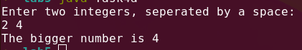
output:

Task 4b:

import java.util.Scanner;

public class Task4b
{
public static void main(String args[])
{
Scanner console = new Scanner(System.in);

System.out.println("Enter two intger:");
int num1 = console.nextInt();
int num2 = console.nextInt();
int min;
if(num1 < num2)
min = num1;
else
min = num2;

System.out.println("The smaller value is "+ min);

}
}

output:


Task 4c:

import java.util.Scanner;

public class Task4c
{
public static void main(String args[])
{
Scanner console = new Scanner(System.in);

System.out.println("Enter an integer:");
int x = console.nextInt();

if (x > 0)
System.out.println("1");
else if (x < 0)
System.out.println("-1");
else
System.out.println("0");

}
}

Output:
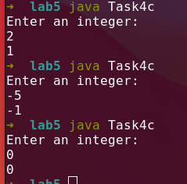

Task 4d:

import java.util.Scanner;

public class Task4d
{
public static void main(String args[])
{
Scanner console = new Scanner(System.in);

System.out.println("Enter three integers, seperated by a space: ");
int num1 = console.nextInt();
int num2 = console.nextInt();
int num3 = console.nextInt();
int min = 0;

if(num1 < num2)
{ if(num1 < num3)
{
min = num1;
}
}

else if(num2 < num3)
{ if(num2 < num3)
{
min = num2;
}
}
else if(num3 < num1)
{
if(num3 < num2)
{
min = num3;
}
}

System.out.println("The minimum number is " + min);

}
}

Output:
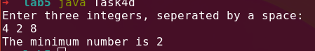

Task5:

import java.util.Scanner;

public class Task5
{
public static void main(String args[])
{
Scanner console = new Scanner(System.in);

System.out.println("Enter three integers: ");
int num1 = console.nextInt();
int num3 = console.nextInt();
int num2 = console.nextInt();
int numOfEqualIntegers = 0;

if(num1 == num2)
{
numOfEqualIntegers=2;
if(num1 == num3)
numOfEqualIntegers=3;
}
else if(num2 == num3)
{
numOfEqualIntegers = 2;
if(num2 == num1)
numOfEqualIntegers = 3;
}
else if(num1 == num3)
{
numOfEqualIntegers = 2;
if(num2 == num1)
{
numOfEqualIntegers = 3;
}
}
System.out.println("The number of equal integers: "+numOfEqualIntegers);

}
}

Output:

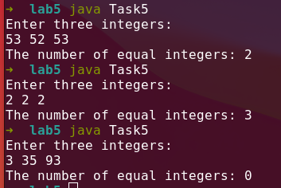

Task6:

import java.util.Scanner;

public class Task6
{
public static void main(String args[])
{
Scanner console = new Scanner(System.in);

System.out.println("Enter a number from 0 to 10:");
int num = console.nextInt();
String romanNumber = "";
switch(num)
{
case 1:
System.out.println("I");
break;

case 2:
System.out.println("II");
break;

case 3:
System.out.println("III");
break;

case 4:
System.out.println("IV");
break;

case 5:
System.out.println("V");
break;

case 6:
System.out.println("VI");
break;

case 7:
System.out.println("VII");
break;

case 8:
System.out.println("VIII");
break;

case 9:
System.out.println("IX");
break;

case 10:
System.out.println("X");
break;
default:
System.out.println("Invalid Input!");
}//end of switch statement
}//end of main method
}//end of class
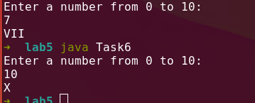
Output:

Task7:

import java.util.Scanner;

public class Task7
{
public static void main(String args[])
{
Scanner console = new Scanner(System.in);

System.out.println("Enter the length and width of the first rectangle: ");
double lenghthRectangle1 = console.nextDouble();
double widthRectangle1 = console.nextDouble();

double areaRectangle1 = lenghthRectangle1*widthRectangle1;

System.out.println("Enter the length and width of the second rectangle: ");
double lenghthRectangle2 = console.nextDouble();
double widthRectangle2 = console.nextDouble();

double areaRectangle2 = lenghthRectangle2 * widthRectangle2;

if(areaRectangle1 > areaRectangle2)
System.out.printf("The rectangle with length %.2f and width %.2f has greater Area", lenghthRectangle1,widthRectangle1);

else if(areaRectangle2 > areaRectangle1)
System.out.printf("The rectangle with length %.2f and width %.2f has greater Area", lenghthRectangle2,widthRectangle2);
else
System.out.println("Both the rectangles are equal in Area.");

}
}

Output:
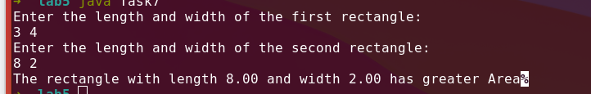

Task8:

import java.util.Scanner;

public class Task8
{
public static void main(String args[])
{
Scanner console = new Scanner(System.in);

System.out.println("Enter the date in the following format: month/day/year. each seperated by a space:");
int month = console.nextInt();
int day = console.nextInt();
int year = console.nextInt();

if(month * day == year)
System.out.printf("%d/%d/%d is magic!",month,day,year);
else
System.out.printf("%d/%d/%d is not magic!",month,day,year);
}
}
Output:

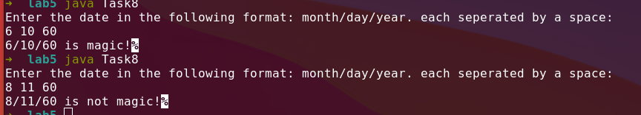

Task9:

import java.util.Scanner;

public class Task9
{
public static void main(String args[])
{
Scanner console = new Scanner(System.in);

System.out.println("Try to Enter the number of pennies,nickels,dimes and quarters that can be combined to make one exactly complete dollar:");
int pennies = console.nextInt();
int nickels = console.nextInt();
int dimes = console.nextInt();
int quarters = console.nextInt();

// converting the coins to their respective dollar amounts and then adding them and //saving the result in combinedEnteredAmount.

double combinedEnteredAmount= pennies*0.01 + nickels*0.05 + dimes*0.10 + quarters*0.25;

if(combinedEnteredAmount == 1)
System.out.println("Congrats! you won the guessing game!!!");
else if (combinedEnteredAmount > 1)
System.out.println("Your entered amount was greater than one dollar.");
else
System.out.println("Your entered amount was less than one dollar.");

}
}

Output:

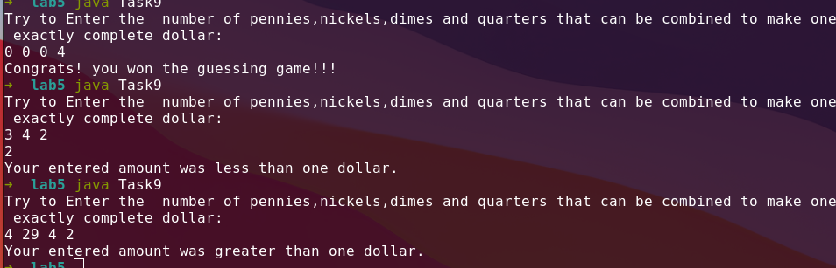

Task 10:

import java.util.Scanner;

public class Task10
{
public static void main(String args[])
{
Scanner console = new Scanner(System.in);

System.out.println("Enter the amount of boooks purchased this month:");
int purchasedBooksAmount = console.nextInt();
int points = 0;
if(purchasedBooksAmount == 1)
points += 5;
else if( purchasedBooksAmount == 2)
points += 15;
else if( purchasedBooksAmount == 3)
points += 30;
else if( purchasedBooksAmount >= 4)
points += 60;

System.out.println("You have been awarded "+ points + " points");
}
}

Output:

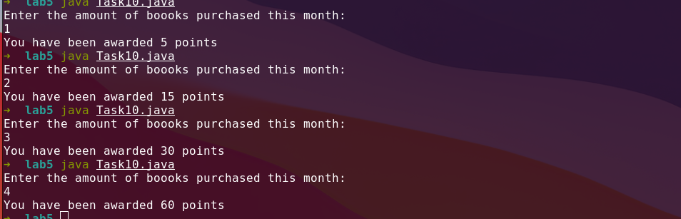

Note:
Sorry the code readibilty is not upto par.

